LAB NO# (4)
• LAB TITTLE:
“TO PRINT THE PROGRAM THAT SHOWS THE NUMBER IS EVEN OR ODD USING CONTROL STATEMENTS IF &IF ELSE AND PRINT THE GRADING SYTEM USING THESE STATEMENT”.
• OBJECTIVE:
PRITNT THE PROGRAM THAT SHOWS NUMBER IS EVEN OR ODD AND GRADING SYSTEM OF YOUR SUBJECT.
• TOOLS:
CODE BLOCKS SOFTWARE:
• PROCEDURE:
- First of all open the code block software in your Pc/Laptop.
- Then create a new project in C++ and save in some folder.
- Then start typing your program that you want to type.
- To print a print a program that shows that number is even or odd we use control statements if or if else.
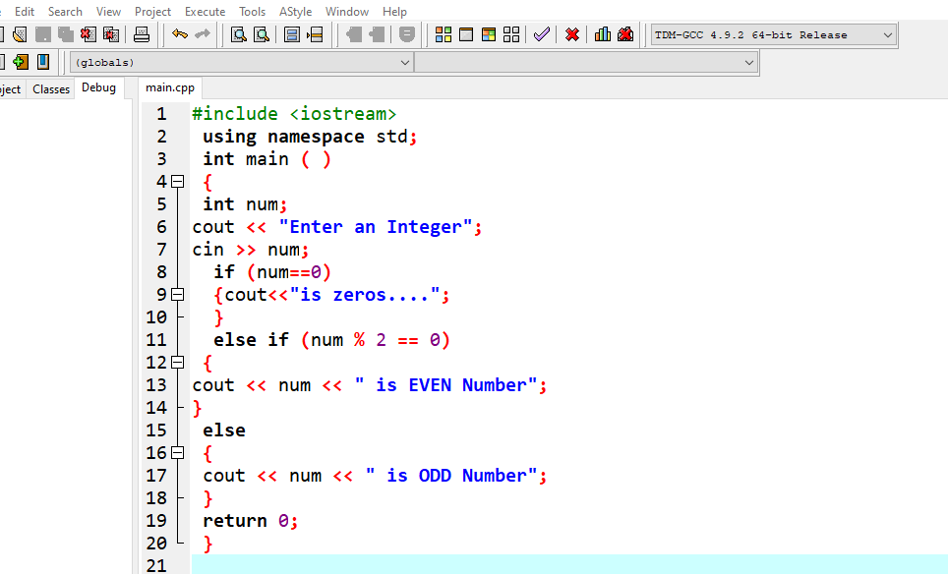
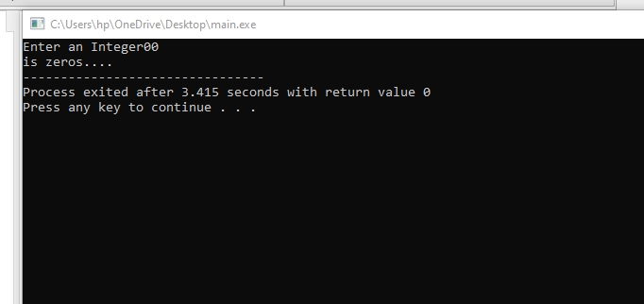
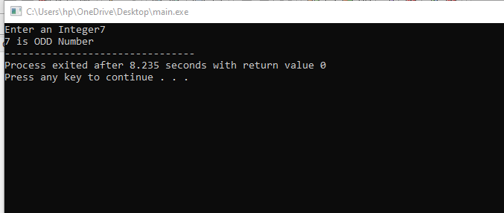
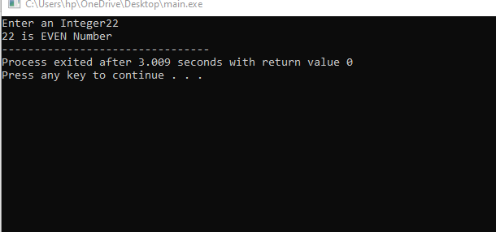

5. Now if you want to print the grading system that you enter you enter your marks and its show your grade.

